SD Determinations

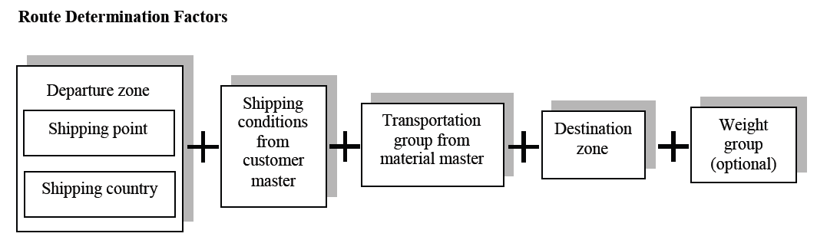

**Account Determination**



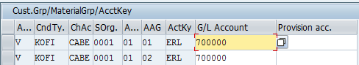

**Item Category Determination**

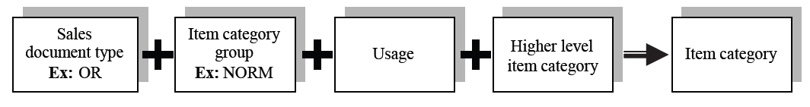

**Schedule line Category Determination**

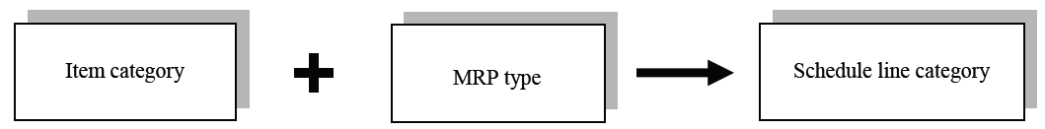

**Shipping Point Determination**



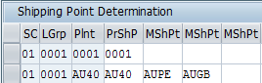

**Pricing Procedure Determination**

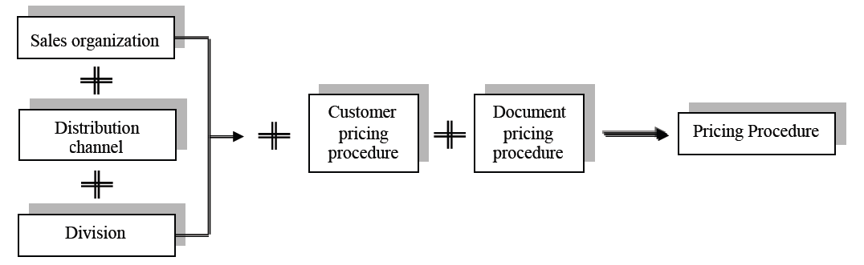

**Consignment Process**

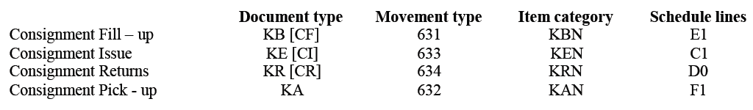

**Bill of Material**

**ERLA**

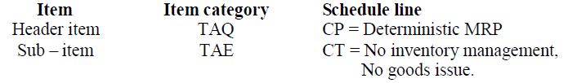

**LUMF**

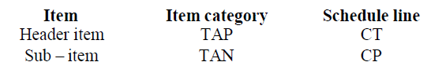

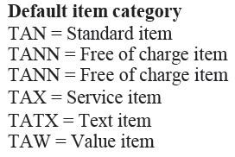

**Stock Transport Order**

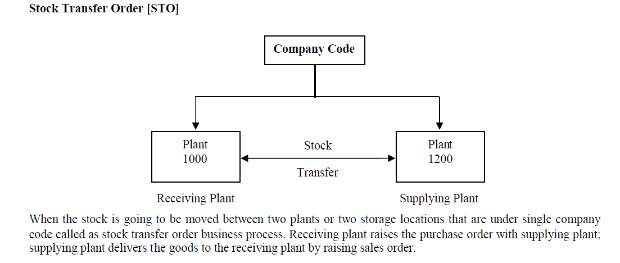

**Configuration Step**

Create Vendor : XD01

Assign Plant to Vendor

Create Customer Master

Define Shipping Data for Plants

Setup Stock Transport Order

Define Shipping Data for Plants

Here we have to assign customer number to receiving plants

Extend the Material Both Plants

**End User**

Create PO - Document type UB

Collective processing of documents due for delivery - Vl10B

specify PO Number & Material -- Click background button and note down SD number

Goto change mode VL02N - Issue PGI

Then -- Display in stock transit

Then Do Goods Receipt : MIGO

Stock Movement Type INTRA and INTER

